Washington baseball players help Piedmont residents Brady Aymond, Staff writer 8:43 p.m. CDT May 1, 2014

Members of the Washington High baseball team were hard at work Thursday, helping residents of Piedmont Road clean up after flood damage.
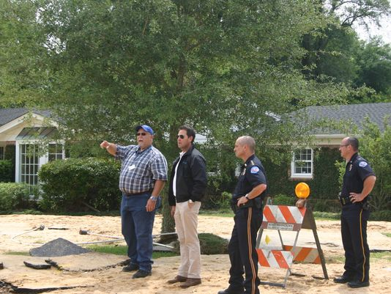
Pensacola Mayor Ashton Hayward surveys the damage on Piedmont Road. Hayward grew up in the neighborhood and said seeing the damage was quite surreal. (Photo: Brady Aymond/baymond@pnj.com ) Washington High junior baseball player Griffin Ricketson can’t count the number of times he has ridden down Piedmont Road in his lifetime. Thursday morning, he and a group of his teammates were back on Piedmont, this time lending a helping hand to neighbors trying to clean up and pick up the scattered pieces of their homes and lives. “I think it was important to be out here because we just need to show that even through all this bad stuff happening, there’s still love in this community,” Ricketson said. “There’s still great people in this community that need help, and it shows that God’s love is just going to bring this community together and make it stronger.” Washington coach Nate Espy sent emails and text messages out to his team late Wednesday asking for players to show up at the corner of Hallmark and Piedmont to help out at his old little league coach LaDon Boyd’s home. By 9:30 a.m., at least 10 Wildcats were there to do whatever was needed. “Really, we’ve just done whatever was asked of us,” Espy said. “We’ve done a lot of cleaning. I think a lot of the houses here have just had a lot of mud and moisture in their homes. They’ve had to get a lot of this stuff out and wash the stuff, wash the floors. “We’ve done a lot of washing, a lot of moving furniture, things like that. A lot of people are having to sort through items — what can they keep, what can they get rid of? It’s been a combination of things. Tasks that just require a lot of manpower, and we’re happy to provide that.” The players showed up not expecting any kind of compensation, really any kind of praise. Of course, that changed when Pensacola Mayor Ashton Hayward arrived in the area mid-morning to survey the damage and speak to residents. Hayward saw the players hard at work and decided to reward them with pizza for lunch. “I thought it was amazing,” Hayward said. “I grew up in this neighborhood, so the house they were helping the folks out, a buddy of mine lived there, and I had been in that house plenty of times. “This morning, I was out with the engineering crew walking Piedmont and letting the families know what our plan was, and I saw the kids out there and I said ‘Listen, y’all need some food.’ My wife had gone out and gotten some food for the people at Manna, so I called her up and said why don’t you come get these baseball players some food. So she went and got them some pizza.” Like Ricketson and many of the Washington High players helping out Thursday, Hayward grew up in the area near Piedmont. To see the devastation firsthand was quite jarring. “I can tell you, I’m 45 now, but I’ve driven this road on my bike thousands of times when I was a child,” Hayward said. “Yesterday when we all showed up, you walked out of your front door and it was a river. It was surreal at the time and for the folks here, it’s the real deal and reality is setting in. So most importantly is to get on top of this as fast as we can and work together as a team. “People want to help each other. My office was packed with people wanting to volunteer. We’re building a community in Pensacola and in times like this, in crisis, people come together. I think you’re going to see our community bigger and better after we get through this, but we will have to get through this as a team.”

