Pensacola trio helps North squad win FACA All-Star Brady Aymond, Staff writer 11:57 p.m. CDT May 28, 2014
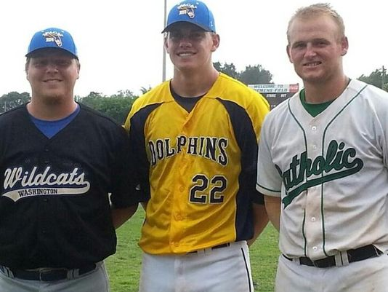
Washington’s Jacob Kelly, Gulf Breeze’s Garrett Peek and Catholic’s Cody Henry pose together after helping lead the North to the FACA All-Star title. (Photo: Submitted photo , Submitted photo
Pensacola is home to a state champion in baseball, after all. Three area players — Washington High's Jacob Kelly, Catholic's Cody Henry and Gulf Breeze's Garrett Peek — took part in the Florida Athletic Coaches' Association All-Star baseball series at Sebring's Firemen's Field and helped the North team take home the state championship trophy with wins against the South and West in the four-team tournament. The best of the best from around the state are chosen to play in the game, and the trio from Pensacola played a big part in helping the North team top the rest of the field. "I guess you could say it was a surprise," Gulf Breeze's Peek said of the North team winning the tournament. "I knew we would be good, but the South team seems to beat the North team every year in the first game. Going into the game against the South, I knew we had a chance. "We went in there and did our job and came back and beat the West team the next day." Pace coach Charlie Warner also had a hand in the victory, serving as an assistant coach for the North squad in his final coaching appearance before moving over to the athletic director position at Pace High in the fall. The North beat the South 5-2, then edged the West team in the championship game Sunday by a 4-3 margin. In Saturday's semifinal win against the South, Kelly tossed the final two innings of the game and earned a save after striking out the last four batters he faced. "It was a great experience," said Kelly, who has signed with Northwest Florida State College. "There was a lot of really good players down there. I actually found out on Friday at practice that I would be closing the game on Saturday. "I closed one game last year, in the championship game of the Aggie Classic. I think it actually helped me, because I got to see what the hitters were doing. I got to watch them and then go out there and do what I thought would get them out." Kelly gave up a hit to the first batter he faced, but got a double play then a strikeout to get out of that inning. In the next inning, Kelly struck out all three batters he faced to nail down the win. "I was a little nervous when I was warming up in the bullpen," Kelly said. "After I started warming up, I calmed down and felt confident. I went out there and performed. "I think I definitely proved that I could compete on that level." Peek pitched in the middle two innings of Saturday's championship game, giving up only one hit and one unearned run. "It was a wonderful opportunity," said Peek, who has signed to play at UAB. "I got to play with some of the best in Florida. It was a great experience. I thought I was just going to go down there, throw one game and be done. I went down there and got to play with some kids that will be picked super high in next week's MLB draft. "I got to play with some of the best kids in the nation. It definitely tested my skills, and got to see how I stacked up against them." Henry, the lone position player from the area in the game, played third base and catcher during the weekend. He walked and was hit by a pitch Saturday and drove in a run Sunday. His biggest contribution came defensively as he threw out the potential game-tying run at third base and a caught stealing with two outs in the ninth inning. "He tried to steal third, and I threw him out at third," Henry said. "It was pretty good. I guess to end the last game, getting the last out like that, it felt pretty good. I'm surprised he tried to steal with two outs." Henry hasn't played catcher that much during the past three years after settling into his role at third base. But catcher could be his future at Alabama when he reports in July. "It came pretty natural to me," Henry said of getting back at catcher. "The guys I caught were all pretty good. They threw a lot of strikes, hit their spots pretty good. "I'm probably going to catch at Alabama. If I hit the ball, I'll have a chance to play. That's the main thing. I have to hit the ball." The championship aside, the trio from Pensacola said the highlight of the weekend was hanging around with each other, as well as the other players competing in the game. "I thought it was really cool to hang out with them," Peek said. "I've played against them for the past five years. There's been a couple of showcases where we were on the same team, but this is where we really got to bond and make friendships. "It was fun because I'll be playing against Cody in college baseball. UAB and Alabama play each other, so we'll see each other again."

